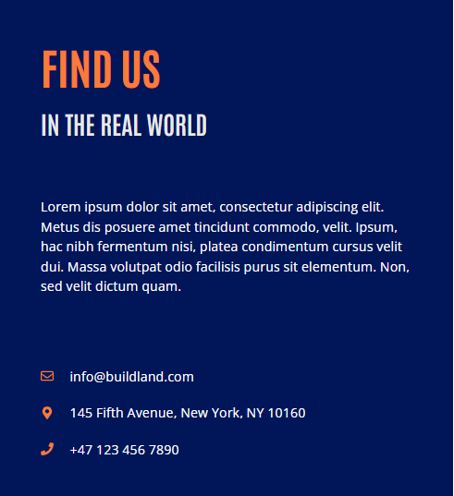

Your Project Deserves a Conversation
Let’s Meet Up
At MAB Building Contracting LLC, our biggest goal is to ensure your happiness. We’re more than a UAE-based construction company. We’re a crew of skilled, driven professionals who treat every project like it’s our own. From foundations to finishes, we chase perfection. Got a vision for your next project? Let’s talk. Together, we’ll turn ideas into steel, glass, and concrete, crafting spaces that don’t just stand tall but make you proud. Your dream. Our obsession. Ready to start? So are we.

